**LARGEST NUMBER IN AN ARRAY**  
  
**EXP NO: 10**  
  
**AIM:**To find the largest number from an array using 8085 processor.  
  
**ALGORITHM:**  
  
1)      Load the address of the first element of the array in HL pair.  
  
2)      Move the count to B register.  
  
3)      Increment the pointer.  
  
4)      Get the first data in A register.  
  
5)      Decrement the count.  
  
6)      Increment the pointer.  
  
7)      Compare the content of memory addressed by HL pair with that  
of A register.  
  
8)      If carry=0, go to step 10 or if carry=1 go to step 9  
  
9)      Move the content of memory addressed by HL to A register.  
  
10)  Decrement the count.  
  
**PROGRAM:**

LXI H,2050  
MOV C,M  
DCR C  
INX H  
MOV A,M  
LOOP1: INX H  
CMP M  
JNC LOOP  
MOV A,M  
LOOP: DCR C  
JNZ LOOP1  
STA 2058  
HLT  
  
  
 

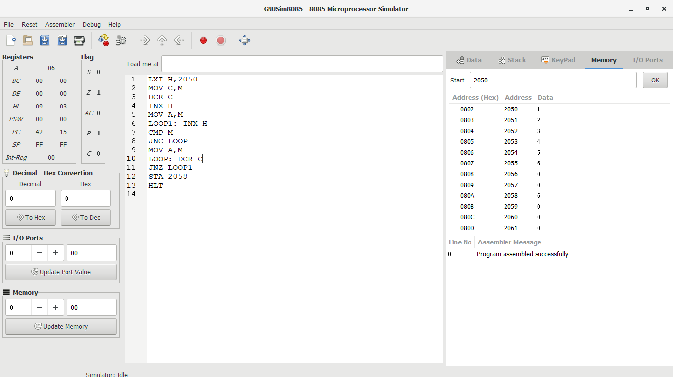**INPUT:**  
  
  
 

**OUTPUT:**  
  
  
 

**RESULT:**

Thus  
the program was executed successfully using 8086 processor simulator.